Solutions & Doubts for Inter IIT Questions

Link for Inter IIT 2019-20 : [https://docs.google.com/document/d/e/2PACX-1vRrEqBNm5jh7DCc_6JI4ZbDmvZvnQqEC8_kfc2r8ULikjz6GH4A5sKBjedEoFoCLvhWvzsI9aKRxuYc/pub?fbclid=IwAR13cplLsR6dvNVORrR13webiNEUKLViwUGjQFYaCwFeQRJlTBOnfdcXdAPpI](https://docs.google.com/document/d/e/2PACX-1vRrEqBNm5jh7DCc_6JI4ZbDmvZvnQqEC8_kfc2r8ULikjz6GH4A5sKBjedEoFoCLvhWvzsI9aKRxuYc/pub?fbclid=IwAR13lLsR6dvNVORrR13webiNEUKLViwUGjQFYaCwFeQRJlTBOnfdcXdAPpI)

Suggestions / Guidelines :

1. Please do not delete anything
2. Try not to write entire code here, instead use some platform & share link (e.g. <https://pastebin.com/> , <https://snipper.io/> , <https://codeshare.io/> etc..)

|  |  |  |  |
| --- | --- | --- | --- |
| Microsoft | Goldman Sachs | Google |  |
|  |  |  |  |
|  |  |  |  |

**[Microsoft]** [Doubt] [Solved]

Q : Minimum adjacent swap required to make a string palindrome.

<https://www.codechef.com/problems/ENCD12>

Solution is here : <https://www.codechef.com/viewsolution/26846686> But it is giving wrong ans in some cases.

Correct solution : <https://www.codechef.com/viewsolution/27727919>

**[ Goldman Sachs ]**

1. A person wants to visit the doctor on alternate days, and since he is forgetful he doesn't remember if he went to the doctor the previous day or not. So he decides that if he starts going on an odd day, he will go on all odd days and similarly for even. The input is a 3 integers, year, month and day. You are supposed to answer how many days does he go to the doctor according to the alternate regime. For eg: if year = 2019, month = 3 and day = 31. The output would be 1 as he goes on all odd days and the 1st of April is odd so, he goes the next day as well. Hence he only went according to routine on the first day.

Solution - <https://pastebin.com/9XaEzf6S>

sol2:<https://ideone.com/ZawffZ>

1. A series is defined such that if we have n, we have to subtract the leftmost digit from the number until we reach 0. For eg: let N = 11, then the series is 11, 10(11 - 1), 9(10 - 1), 0(9 - 9). Now we are given an input K(length of sequence) , we have to determine the number N such that N is maximum when we have a series with K elements. Eg, for K = 3, we have output as 10 as is deducible from the above explanation.

Solution - <https://pastebin.com/sp9UqrGy>

1. Almost Sorted Array - find minimum nos. that must be deleted so that array is almost sorted. (An array is almost sorted if it can be sorted by deleting at most 1 element.) Eg 2,1,5,4,6 So answer is 1. As if we delete 1 or 4 we get almost sorted array. Can be solved using nlogn version of LIS (Same as Appdynamics IIT Kgp)

Solution - <https://pastebin.com/qA4Lhnba>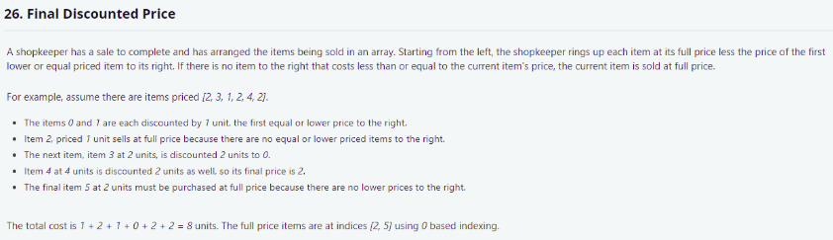

4.

Solution: Next Smaller element

1. Add the last element to a stack and also add this to the result.
2. Now start iterating from the second last element and if the element is smaller than the top of the stack keep popping the elements greater than the element.

If the element is greater than the stack’s top just push the element.

1. Add the difference of element and stack’s top to the result before pushing the element to the stack.
2. The full price items are those for which stack got empty before pushing these items.

###### **[ Google ]**

1.Cost of hiring, Salary and severance fee was given. Minimum employee count( required for that particular month is given. p.s. you can have more employees than this value but not less) of N months are given. Calculate the min cost for running the company.

Exact ques:<https://www.spoj.com/problems/MKBUDGET/>

Sol(Accepted in spoj):<https://ideone.com/MIastR> (Backtracking+Memoization)

Sol(Iterative DP): <https://pastebin.com/40wb5gg9>

2.Given an array of integers, and a number. Find maximum subset sum less than or equal to the number. You cannot select adjacent numbers.

Input: array= {50,5,25,9,40} num=100

Solution: <https://ideone.com/3H0z9P> Please verify this

Another Sol: <https://ideone.com/ds4kgS> Verified Did you submitted somewhere?

###### **[Microsoft]**

Given a string s consisting of n lowercase letters, you have to delete the minimum number of characters from s so that every letter in s appears a unique number of times. We only care about the occurrences of letters that appear at least once in result.

**eeeeffff**

**Ans : 1**

Q :[**https://leetcode.com/discuss/interview-question/398035/**](https://leetcode.com/discuss/interview-question/398035/)

Sol : [**https://pastebin.com/FQJ9wH9R**](https://pastebin.com/FQJ9wH9R)

**Can someone provide the solution for Digit Sum which was asked in Goldman Sachs.**

###### **[Uber]**

**Q1.** [**https://leetcode.com/problems/cherry-pickup/**](https://leetcode.com/problems/cherry-pickup/)

**Solution using 3-D dp O(n^3) :-** [**https://pastebin.com/7fd1He7M**](https://pastebin.com/7fd1He7M)

**Q. Travelling Spy Problem (IIT KGP)**

[**https://imgur.com/a/jfF7arr**](https://imgur.com/a/jfF7arr)

###### **[App Dynamics]**

**[Please use these answers at your own discretion]**

**[Answers are not verified, but they should work]**

1. **Vowels**

* Create an integer array, where Ai =1 if the ith word begins and ends with a vowel, 0 otherwise..
* Now compute the prefix sum array of this array
* Now perform [L,R] Range queries.

1. **Activate Fountain**

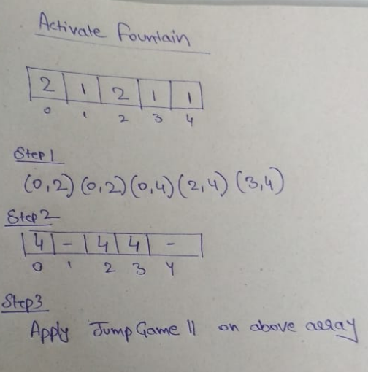

Step 1 : Compute Range of every fountain

Step 2 : For each index, fill the array loc with maximum value which can be reached from there

Ex : from 0 i can reach both 2 and 4, so fill it with 4

Step 3 : <https://leetcode.com/problems/jump-game-ii/>

1. **Connecting Computers**

Step 1: Check if number of edges >= number of nodes - 1

If yes, proceed further

Else, return -1

Step 2: Count number of connected components

Step 3 : Answer is (Number of Connected Components - 1)

1. **Ticket Reseller**

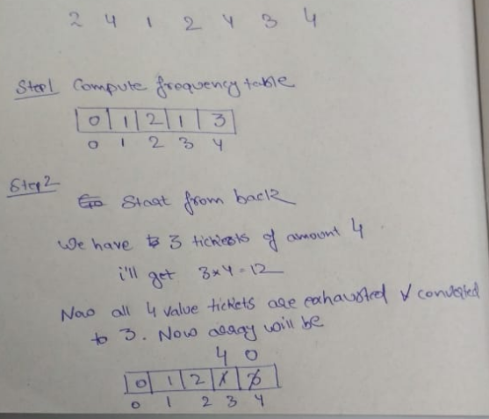

1. **Almost Sorted Array**

Compute LIS using O(nlogn) method.

n=size of array

LIS = length of LIS

Two cases

1. Return n-lis-1